Charter Revision Committee

Meeting Agenda

October 19, 2022

The following meeting has been scheduled for Wednesday, October 19, 2022:

7:00 pm City Charter Revision Committee in the Common Council Chambers

Meeting Agenda:
          - Welcome/Introduction
          - Identification of Roles
          - Process
          - Review of Timeline
          - Discussion of 2021 Summary of Charter Review

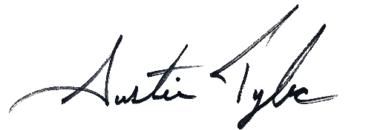
Respectfully submitted,

Austin Tylec
Mayor

